Q1

Sample average $\overline{x}= 467.4876$ mean(BODYMASS, 'omitnan')

Sample standard deviation *s* = 288.3465 std(BODYMASS, 'omitnan')

Q2

1. Regression
2. Extrapolation

Q3

function result = sum_to_n(arr, n)

arr_length = length(arr)

result = []

% If the number of elements in the array is less than 2,

% does not apply to this function.

if arr_length < 2

return;

end

for i = 1:arr_length - 1

for j = i + 1:arr_length

if arr(i) + arr(j) == n

result = [result; arr(i) arr(j)];

end

end

end

end

Q4

1. The data distribution of x3 presents a bimodal distribution, 50% of the data is concentrated between 12 and 17.

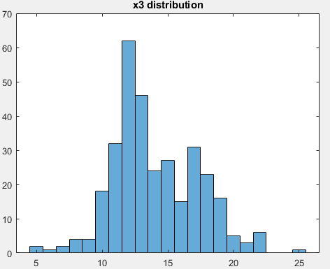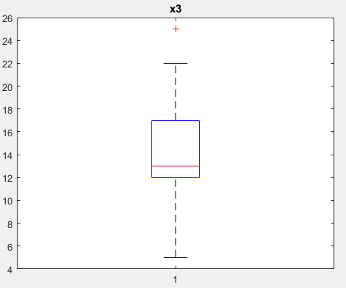

1. x4 and x12 have a positive correlation. x4 and x12 have a linear correlation.
2. The pair of x4 and x12 has the highest correlation, where the covariance is 0.552 and the Pearson correlation coefficient is 0.9423.
3. x3 and x6 present a bimodal distribution, x4 and x12 are skewed right, x2, x7, x8, x10 and x11 present a normal distribution.

Q5

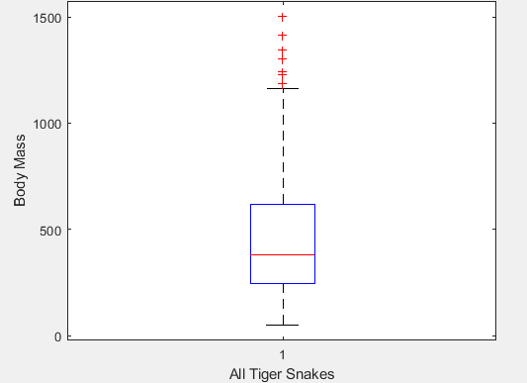

IQR = Q3 - Q1 = 620 - 247 = 373

The value of the data point that lies closest the boundary of the inter-quartile range is 373.3000.

Q6

The relationship between the growth of pumpkins grown on a farm and factors such as light, temperature, fertilization, and watering etc.

The size of the pumpkin should conform to the normal distribution, such as x2, the size is mainly concentrated in the medium and large. The more fertilization and light, the bigger the pumpkins will grow. The growth hormone content in pumpkin has a positive linear correlation with temperature and light, such as x4 and x12.

